**EX NO:1 HTML**

# DATE:28.03.22

**1.a) Design your own web pages containing a description of the personal, education, hobbies, family and friends information etc, use href, list,image, audio, video tags.**

# Aim:

To create a webpage for our own personal details.

# Procedure:

1. Open a HTML file.
2. Give a title for the webpage using <TITLE> tag in <HEAD> section. **3.**In the <BODY> section,the tags for giving color,<p> tag for paragraph **4.**The personal details are written inside the tag.
3. Links for other webpages are linked using <href> tags.
4. Audios and videos are linked using their appropriate tags.

# Program:

# Main Web Page:

|  |
| --- |
| <html>  <head>  <title> Webpage Linking </title>  <h1 style="color:white;"> Detail Description </h1>  </head>  <style>  body  {  background-image: url('image.jpg');  background-repeat: no-repeat;  background-attachment: fixed;  background-size: 100% 100%;  }  </style>  <body>  <ol>  <li> <h1> <a href="/ex1-1.html" >personal information </a> </h1> </li>  <li> <h1 ><a href="/ex1-2.html" > education </a> </h1></li>  <li> <h1 > <a href="/ex1-3.html" > family and friends</a></h1></li>  <li> <h1 ><a href="/ex1-4.html" > hobbies </a></h1></li>  </ol>  </body>  </html>  **Personal Information:**  <html>  <head>  <title> personal information </title>  </head>  <style>  body{  background-color:yellow;  align:center;  }  </style>  <body style="font-size:20">  Name:G.Ghulam Dasthageer<br>  Age:20<br>  Gender:Male<br>  <li>Languages known:<ol>English</ol>,  <ol>Tamil</ol>  <ol>Hindi</ol>  <ol>Urdu</ol>  <ol>Arabic</ol><br>  Email-id:ghualamdasthageer25@gmail.com<br>  Address:No,28 Ansari Nagar,Mahaboob Palayam 5th strret<br>  City:Madurai.    </body>  </html>  **Education Information:**  <html>  <head>  <title> Education Information </title>  </head>  <style>  body{  background-color:pink;  }  </style>  <body style="font-size:40">  <p> I did my schooling at <i> Velammal Matric Hr.Sec.School, Madurai </i></p>  <p> Currently I am pursuing my BE <b> Computer Science Engineering </b> at Velammal college of Engineering and Tecnology ,Madurai.</p>  <p> Batch: "2019-2023"</p>  </body>  </html>  **Family Details:**  <html>  <head>  <title> Family </title>  </head>  <style>    body  {  background-color:pink;  }  </style>  <body style="font-size:40">  Father Name: S.Ghouse Mohideen<br>  Mother Name: S.Mahaboob Begum<br>  Father Occupation: Engineer<br>  Mother Occupation: Home-maker<br>  </body>  </html>  **Hobbies:**  <html>  <head>  <title> Hobby </title>  </head>  <style>    body  {  background-color:grey;  }  </style>  <body style="font-size:40">  <p> My hobbies are:<br>fiteness<br>cooking<br>longtrip in bike </p>  <body>  </html>  **Output:** |
|  |
|  |
|  |
|  |
|  |
|  |
|  |
|  |
|  |
|  |
|  |
|  |
|  |
|  |
|  |
|  |
|  |
|  |
|  |
|  |
|  |
|  |
|  |
|  |
|  |

**1.b)Create a web page with the following using HTML**

# To embed a map in a web page

* + 1. **To fix the hot spots in that map**
    2. **Show all the related information when the hot spots are clicked.**

# Procedure:

1. Open a HTML file.
2. Give a title for the webpage using <TITLE> tag in <HEAD> section.
3. In the <BODY> section,the picture is attached using <img src=” ”> and link iss attached using usemap tag and href for hotspot links.
4. Then create different HTML webpages u=sing the tags for different hotspots.
5. Images are attached using respective tags.

**Program:**

**Map:**

<html>

<head>

<title> Image Mapping </title>

</head>

<body>

<img src="indiamap.jpg" width="1000" height="1194" alt="map" usemap="#workmap">

<map name="workmap">

<area shape="rect" coords="425,903,323,1102" alt="state" href="https://en.wikipedia.org/wiki/tamilnadu">

<area shape="rect" coords="190,821,204,850" alt="state" href="https://en.wikipedia.org/wiki/goa">

<area shape="rect" coords="890,437,877,492" alt="state" href="https://en.wikipedia.org/wiki/manipur">

<area shape="rect" coords="230,932,309,1099" alt="state" href="https://en.wikipedia.org/wiki/kerala">

</map>

</body>

</html>

**Output:**

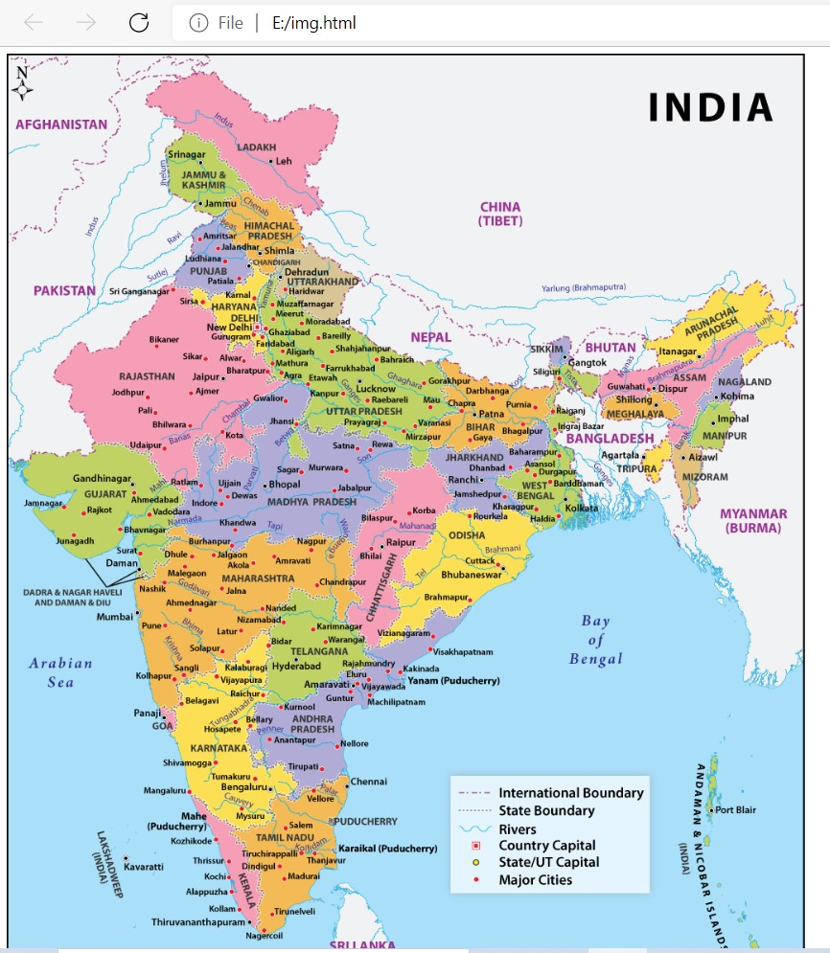

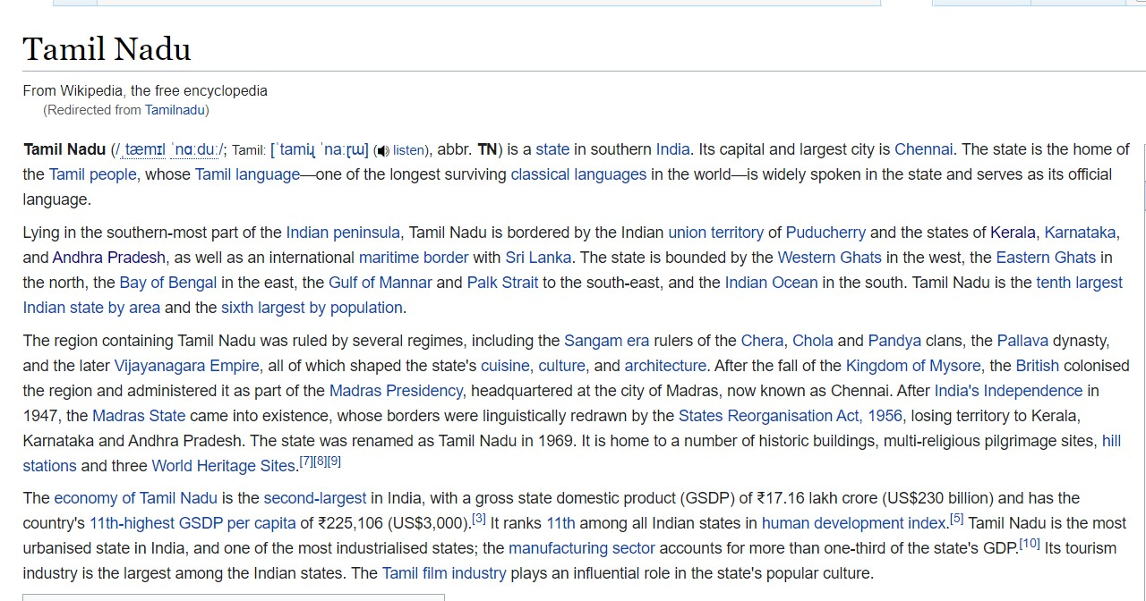

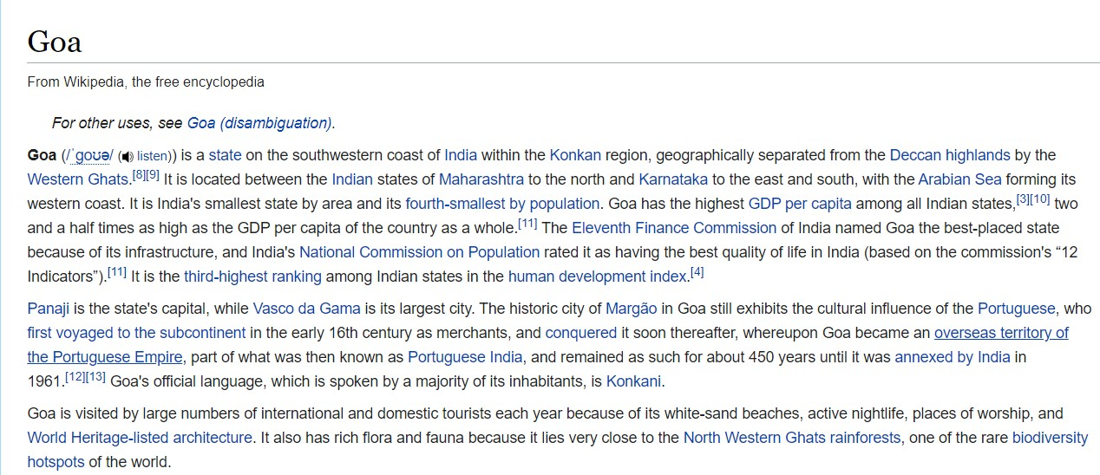

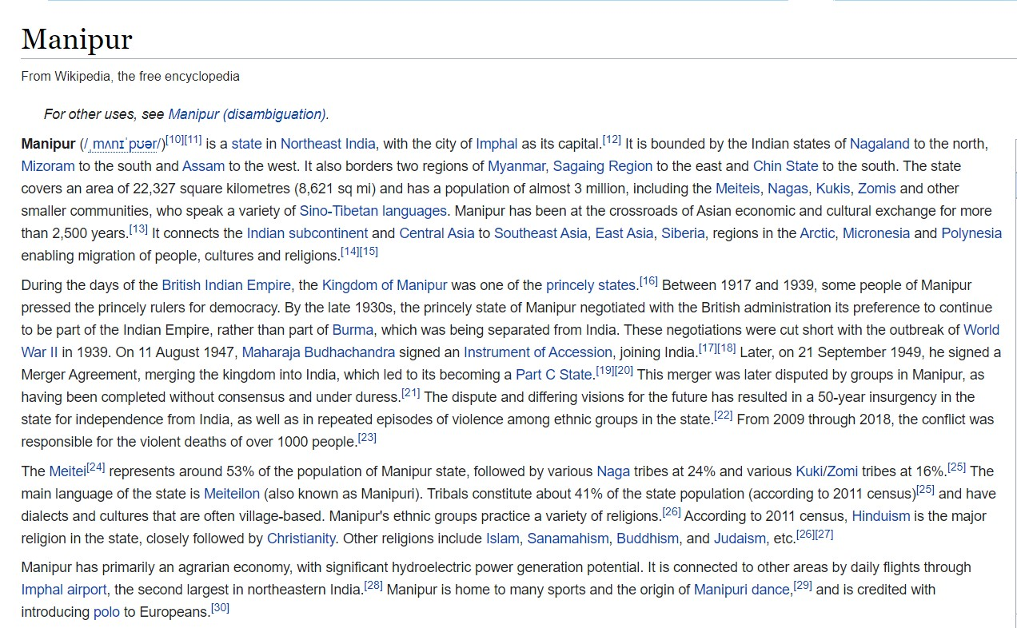

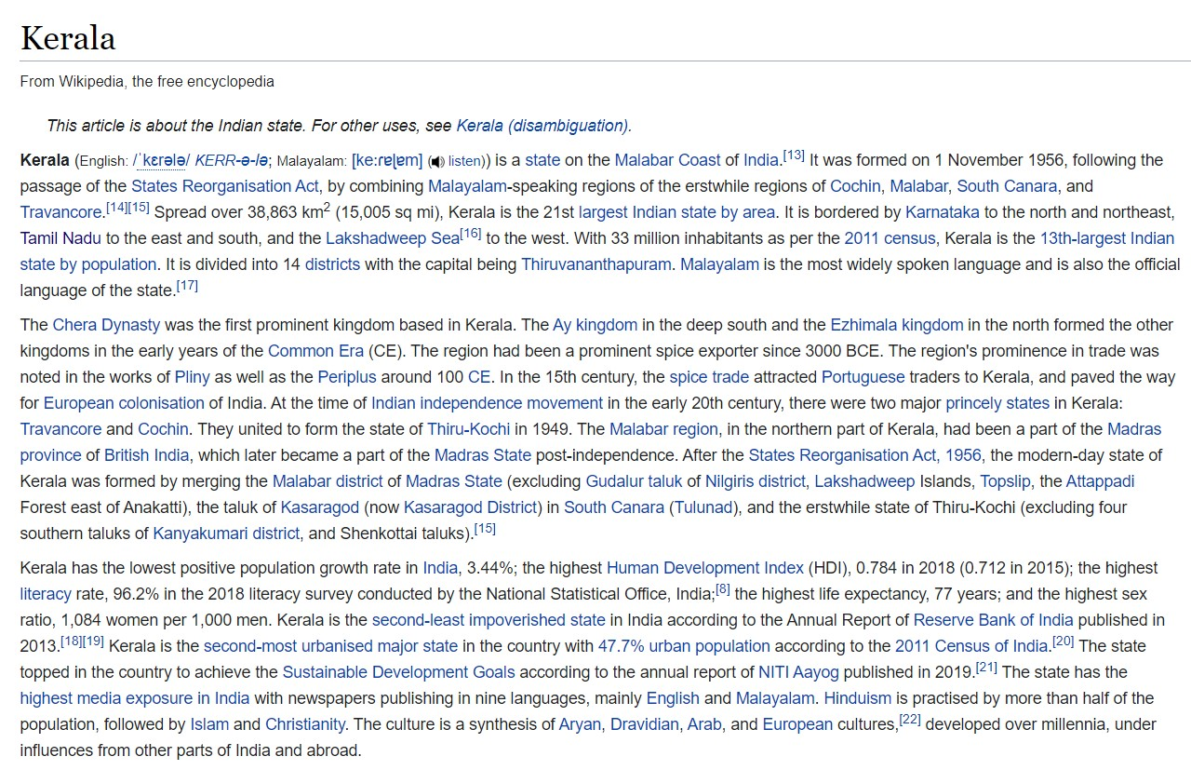

|  |  |
| --- | --- |
| **Observation(20)** |  |
| **Record(5)** |  |
| **Total(25)** |  |
| **Initial** |  |

**Result:**

Thus the webpage is created successfully.